**ANKARA** **UNIVERSITY**

**ENGINEERING FACULTY**

**DEPARTMENT OF COMPUTER ENGINEERING**



**COM 462 PROJECT REPORT**

**ARDUINO BASED MULTI-FUNCTION ROBOT**

|  |  |
| --- | --- |
| **Yunus ÇİFTÇİLER** | **14290084** |
| **Abdullah GÜR** | **14290100** |

**Dr. Öğr. Üyesi Semra GÜNDÜÇ**

|  |
| --- |
|  |

**JUNE 03RD, 2019**

# TABLE OF CONTENTS

TABLE OF CONTENTS 2

ABSTRACT 4

INTRODUCTION 5

1. THE SYSTEM SCHEMATIC REPRESENTATION 6

1.1. Mechanical Design 6

1.2. Electronic Design 9

1.2.1. Arduino UNO 10

1.2.2. Ultrasonic Ranging Detector Mod HC-SR04 Distance Sensor 10

1.2.3. Stepper Motors with L298N Dual Motor Controller Module 11

1.2.4. HC-06 Bluetooth Module 11

1.2.5. DHT11 Temperature & Humidity Sensor 12

1.2.6. GY-NEO6MV2 GPS Module 12

2. ROBOT SOFTWARE FUNCTIONS 13

2.1. Controlling the Robot with Button Commands 13

2.2. How to Work These Robot Motions? 15

2.3. Measuring Temperature & Humidity and Create Temperature & Humidity Graph 17

2.4. How to Measure Temperature & Humidity? 19

2.5. Obstacle Avoidance Mechanism 20

2.6. How to Measure Current Location of Our Robot? 21

2.6.1. What is GPS (Global Positioning System)? 21

2.6.2. Measure Current Location 22

2.7. Save Location from Arduino Serial Monitor to Text File 24

2.8. Display Current Location of Our Robot in the Google Visualizer 26

2.8.1. What does the Google Visualizer do? 26

2.8.2. Display Current Location 27

3. DEVELOP A PROPER APK APP FOR OUR ROBOT 29

3.1. What does MIT APP Inventor Do? 29

3.2. Create the Buttons for Robot Motions 29

3.3. Create the Buttons for Measuring Temperature & Humidity Values 29

4. UML DIAGRAMS OF THE SYSTEM 30

4.1. Use Case Diagram 30

4.2. Activity Diagram 31

4.3. Flow Chart 32

APPENDICES 33

Appendix-1. The Sensors used in the Robot 33

Appendix-2. The Tools used in the Robot 34

CONCLUSION 36

BIBLIOGRAPHY 37

# ABSTRACT

In the first semester, we tried to determine the approximate location of our robot by adding a GPS sensor as extra in this semester in our project which we have reached a certain stage. Thanks to the humidity and temperature sensor, we measured the humidity or temperature value of the robot and the values ​​were written on the map. According to the humidity and temperature values, we tried to show the position on the map in a more beautiful way with various color tones.

Our robot constantly tries to detect the values of the BT (bluetooth) and GPS sensors. The entire flow is repeated several times per second. In this way, we planned to minimize the IT connection problem caused by the transition time between the sensors.

Also in the first semester, we were trying to use 2 different APK app while controlling robot with BT (A separate app for voice command, and for buttons). In this period, we tried to create our own APK by using MIT APP Inventor.[1]

# INTRODUCTION

Over the past decade, mobile robots have withdrawn from the military and industrial environment, entering into civil and personal areas such as hospitals, schools and ordinary homes. Robots are replacing people in performing repetitive tasks. Robot: sensing the surroundings with sensors, interpreting what they perceive, making a decision as a result of interpretation, the device that produces the output with an output signal is called robot. Robots can output this output signal with a motor, LED or any actuator. Devices that cannot make autonomous decisions are not robots.[2] Robots can be divided into two areas: industrial and service robots. The International Robotics Federation defines the service robot as a robot operating partially or completely independently, performing services that are beneficial to the welfare of people. Performing the work in different places requires the robot to be a traveler. Traveling robots designed for such tasks consist of three parts. The first part is the mechanics providing the motion, the second part is the hardware that enables the processing of the detected data by the control units and sensors, and the third part is the software that enables the motion control and decision making.[3]

The aim of this project is to measure the temperature and humidity values of the environment and to see the temperature and humidity of the environment graphically in our phone using this data. It is also to determine where our robot is. Thanks to this robot, we contribute to the economy by reducing the number of manpower used in various regions of the industry. In addition, additional sensors can be added to perform other functions.

We can examine the development phase of our robot in two parts as hardware and software. Hardware, mechanical design and electronic design are presented under two different headings. In the realization of electronic design; Arduino UNO control card, ultrasonic distance sensor, 6V 250 rpm motor, bluetooth module, temperature and humidity sensor, Gy-neo6mv2 GPS sensor using the general diagram is created. Mechanical design; the mechanical body of the robot and the ability to create movement consists of studies. The software part has two different tasks. The first is to detect the obstacle and to protect itself, the second is to create a map of temperature and humidity.

# THE SYSTEM SCHEMATIC REPRESENTATION

## Mechanical Design

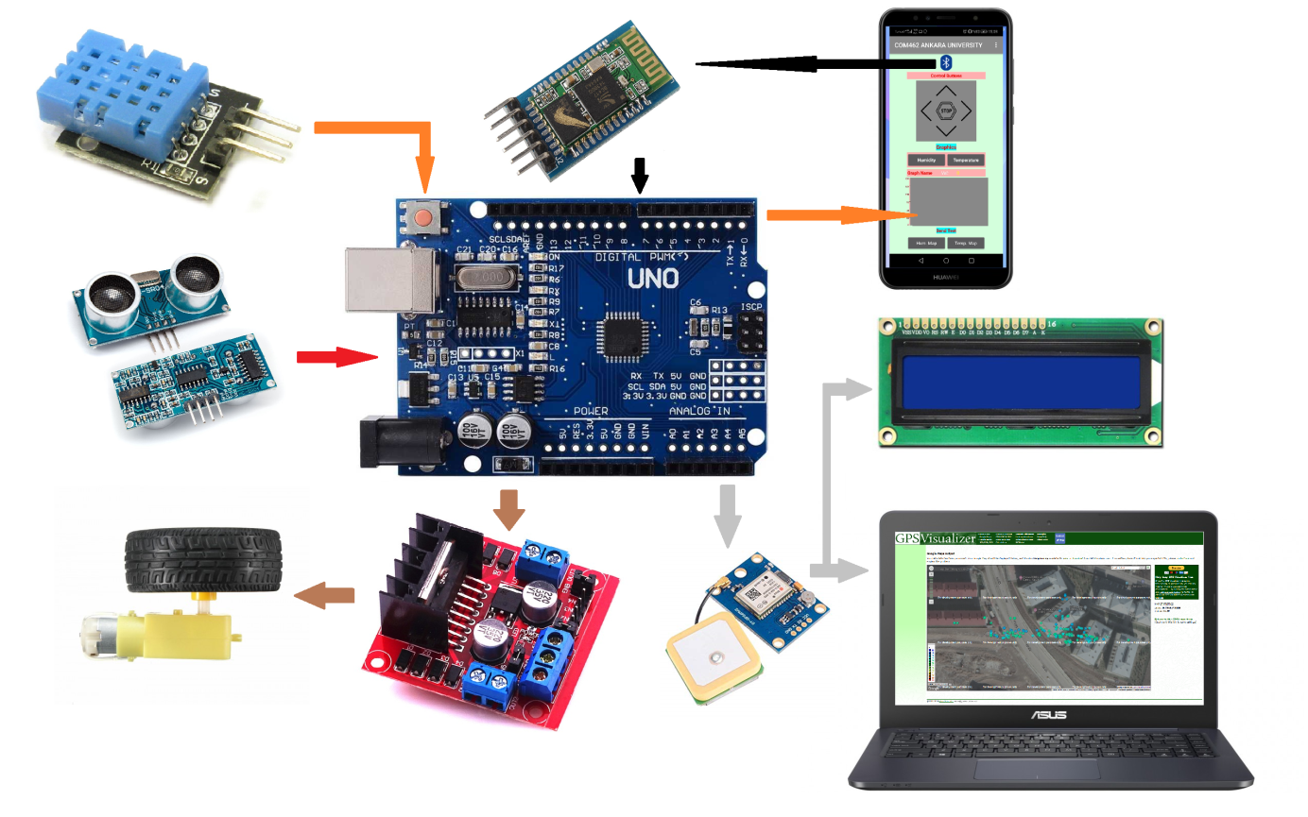

Figure . Simplified General Diagram of the Robot

As shown in **Figure 1.1.1**, the values measured from the temperature and humidity sensor are sent to our APK application on the phone via Bluetooth. Time dependent temperature and humidity graph is created. The GPS sensor also finds the approximate location of the robot and, when connected to the computer, the location values are reflected to the LCD screen and Arduino Serial Monitor via Arduino. In addition, the information from the distance sensor is evaluated on the microcontroller and the corresponding command is transmitted to the motors by the motor driver.

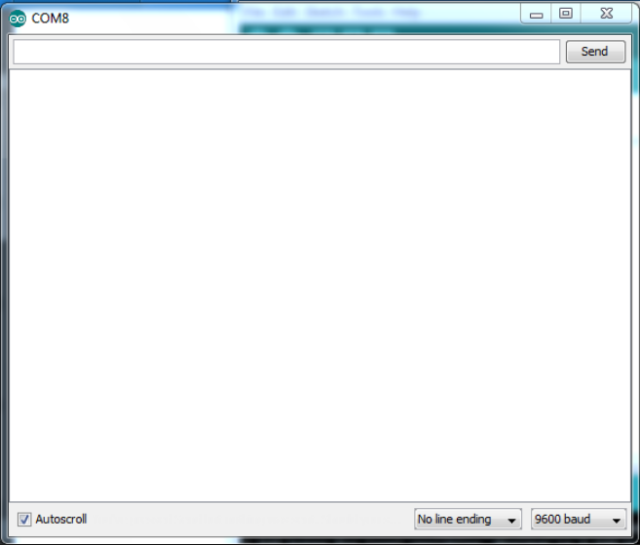

Figure . Arduino Serial Monitor on PC

The basic problem encountered when designing a robot is the mechanical design of the robot. Although this problem can be solved easily with manufacturing, it is not suitable for most situations in terms of cost. The most basic solution to this problem is to create a robot with the help of ready-made modules or to take advantage of the backbone of previously created mechanical strings. In this study, ready module was used. The ready-to-use module is the 4WD Multipurpose Mobile Robot Platform module. The planar movement of the robot is provided by 4 6V 160mA 250rpm DC motors. The engines are powered by the battery. By means of the sensors in **Figure 1.1.1**, it is possible to measure the temperature and humidity values and the distance value so that the robot can decide accordingly.

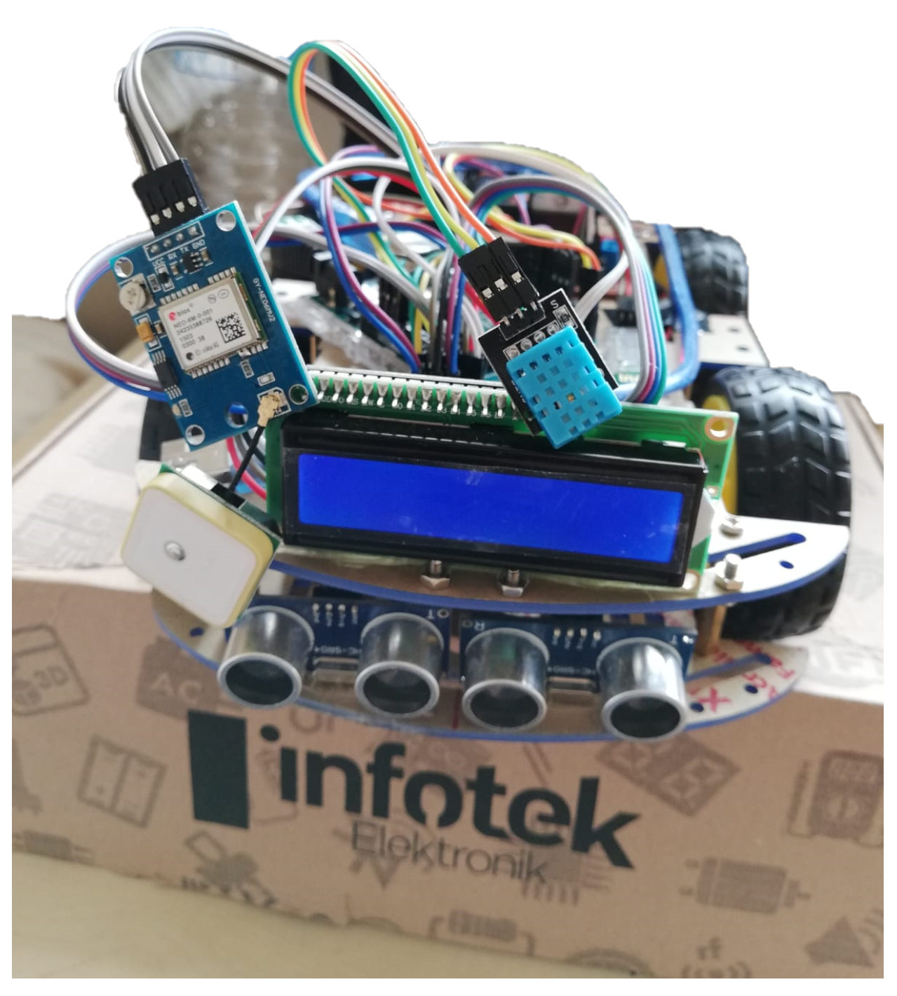

Figure . Mechanical design of multi-sensor robot

## Electronic Design

The electronic design of the robot has been tried to be shown on the PC with the **Fritzing** application.

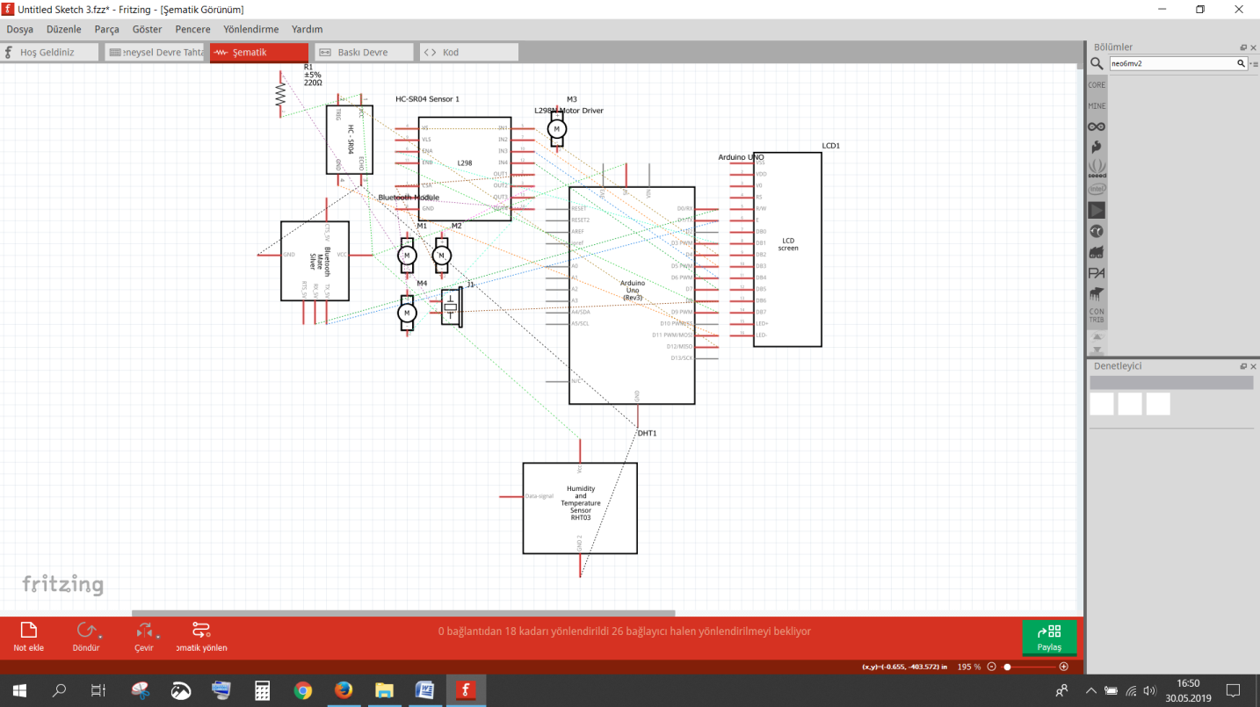Figure . The 4-motors and motor driver schematic apperance

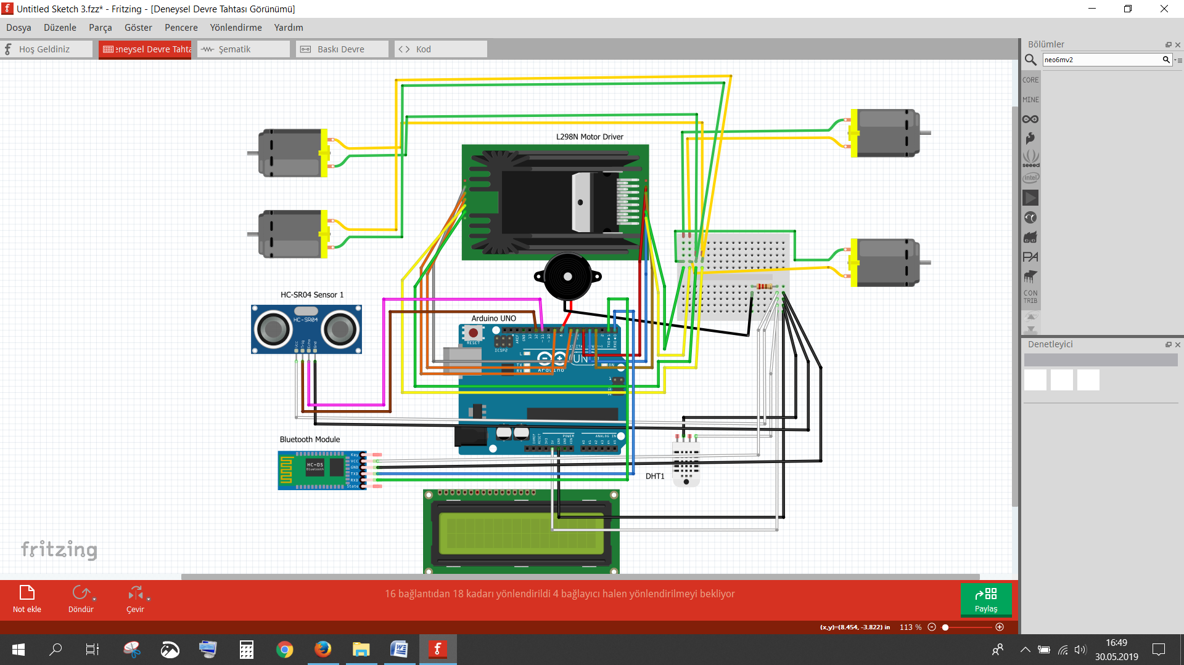Figure . The 4-motors and motor driver physical apperance

### Arduino UNO

Arduino is a physical programming platform consisting of an I/O card and a development environment that includes an application of Processing/Wiring language. Arduino can be used to develop stand-alone interactive objects, as well as software that runs on a computer (Macromedia Flash, Processing, Max/MSP, Pure Data, SuperCollider).

Arduino is an open-source hardware and software company, project and user community that designs and manufactures single-board microcontrollers and microcontroller kits for building digital devices and interactive objects that can sense and control objects in the physical and digital world.[4]

Arduino board designs use a variety of microprocessors and controllers. The boards are equipped with sets of digital and analog input/output (I/O) pins that may be interfaced to various expansion boards or breadboards (shields) and other circuits. The microcontrollers are typically programmed using a dialect of features from the programming languages C and C++.[5]

In our project, we can send the information from the sensors to the Arduino Serial Monitor by using the Arduino UNO control card.

### Ultrasonic Ranging Detector Mod HC-SR04 Distance Sensor

Ultrasonic sensors have been used in autonomous mobile robots to avoid obstacles and to create maps. The sound wave is emitted by the transmitter on the ultrasonic sensor. This sound wave hits the obstacle and reflects. The distance is measured using the elapsed time (flight time) to detect the reflected wave on the ultrasonic sensor.

In this study, 2 HC-SR04 ultrasonic distance sensors were used to measure distance. This allows the robot to scan and view more space. Actually, we could put one of the sensors in the back and control the backward movement. The sensor can measure between 2 cm and 400 cm with 3 mm accuracy.

### Stepper Motors with L298N Dual Motor Controller Module

The L298N is an integrated monolithic circuit in a 15- lead Multiwatt and PowerSO20 packages. It is a high voltage, high current dual full-bridge driver de-signed to accept standard TTL logic level sand drive inductive loads such as relays, solenoids, DC and stepping motors.

Features;

1) High operating voltage, which can be up to 40 volts.

2) Large output current, the instantaneous peak current can be up to 3A.

3) With 25W rated power.

4) Two built in H-bridge, high voltage, large current, full bridge driver, which can be used to drive DC motors, stepper motors, relay coils and other inductive loads.

5) Using standard logic level signal to control.

6) Able to drive a two-phase stepper motor or four-phase stepper motor, and two-phase DC motors.

7) Drive voltage: 5-35V; logic voltage: 5V.[6]

In this study, Motor Controller Card is used to apply the commands from Arduino.

### HC-06 Bluetooth Module

The HC-06 is a class 2 slave Bluetooth module designed for transparent wireless serial communication. Once it is paired to a master Bluetooth device such as PC, smart phones and tablet, its operation becomes transparent to the user. All data received through the serial input is immediately transmitted over the air. When the module receives wireless data, it is sent out through the serial interface exactly at it is received. No user code specific to the Bluetooth module is needed at all in the user microcontroller program.

In this study, we can send commands to the robot via the phone via the appropriate module.

### DHT11 Temperature & Humidity Sensor

The DHT11 Temperature and Humidity Sensor Board is a module with a DHT11 sensor that is designed to be used for a breadboard or for different uses. The DHT11 temperature and humidity sensor is an advanced sensor unit that outputs a calibrated digital signal.[7]

As a temperature and humidity sensor, it is possible to find many different types of humidity sensors in the market. However, the DHT11 sensor library is defined in the Arduino environment. Therefore, the temperature and humidity sensor known as DHT11 was used in the robot.

### GY-NEO6MV2 GPS Module

The GPS module for Arduino is a small electronic circuit that allows to connect to your Arduino board to get position and altitude, as well as speed, date and time on UTC (Universal Time Coordinated). It uses the standard NMEA protocol to transmit the position data via serial port.[8]

This card with GY-NEO6MV2 module is a product that you can use to control and track position in many projects, especially flight control systems. High quality and precision module is frequently used in projects requiring location information via GPS. It has a sensitivity of about 5, 10 meters.[9]

# ROBOT SOFTWARE FUNCTIONS

In this section, all software functions of the robot will be explained in detail.



## Controlling the Robot with Button Commands

We can connect to the robot via bluetooth module, and we use our APK app for move our robot with the button.

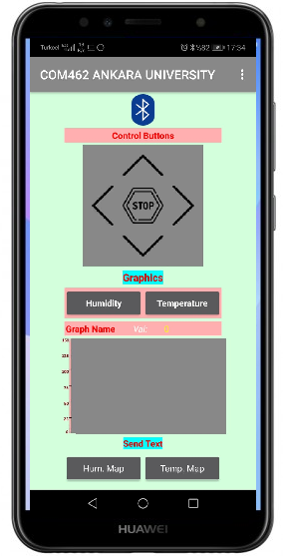

Figure . Our phone application

The following code provides this function:

“**\*\*\*\*\*\*\*\*\*\***”[10]

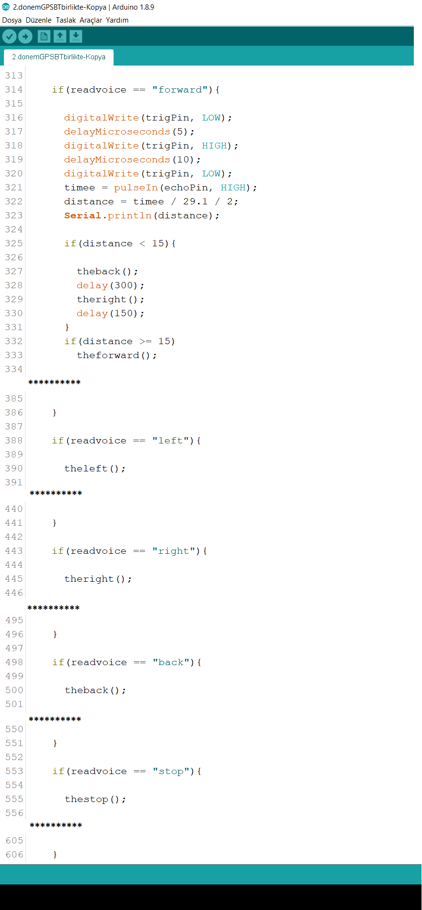 Figure . This code snippet shows how to controlling the robot

## How to Work These Robot Motions?

We’ll show how the functions that provide the robot movements mentioned in **Section 2.1** work and we define the pins in the motor output to provide these functions to work and the enable pin to make the engines available.

In the **void setup()** function, we define which pins are input and which pins are output.

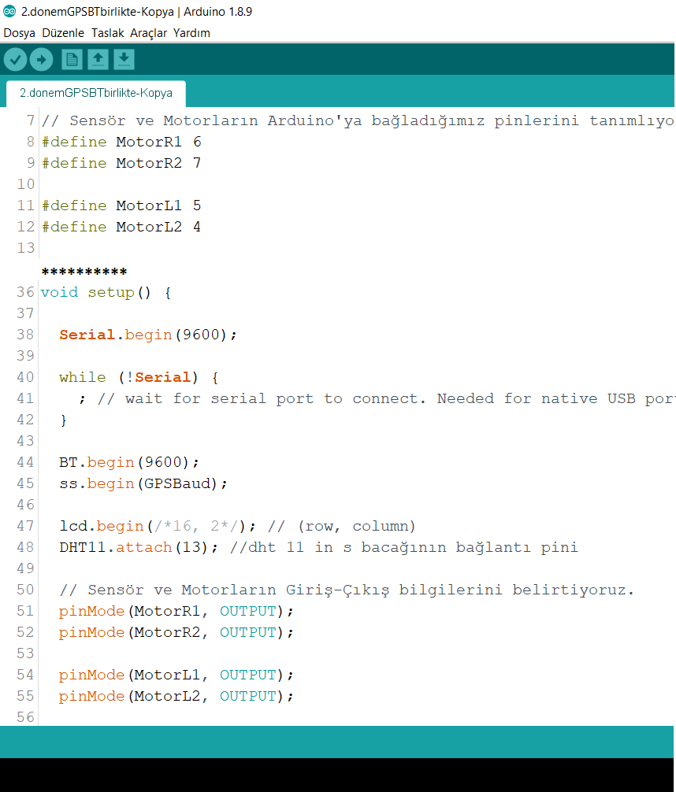 Figure . This code snippet defines required pins for robot motion

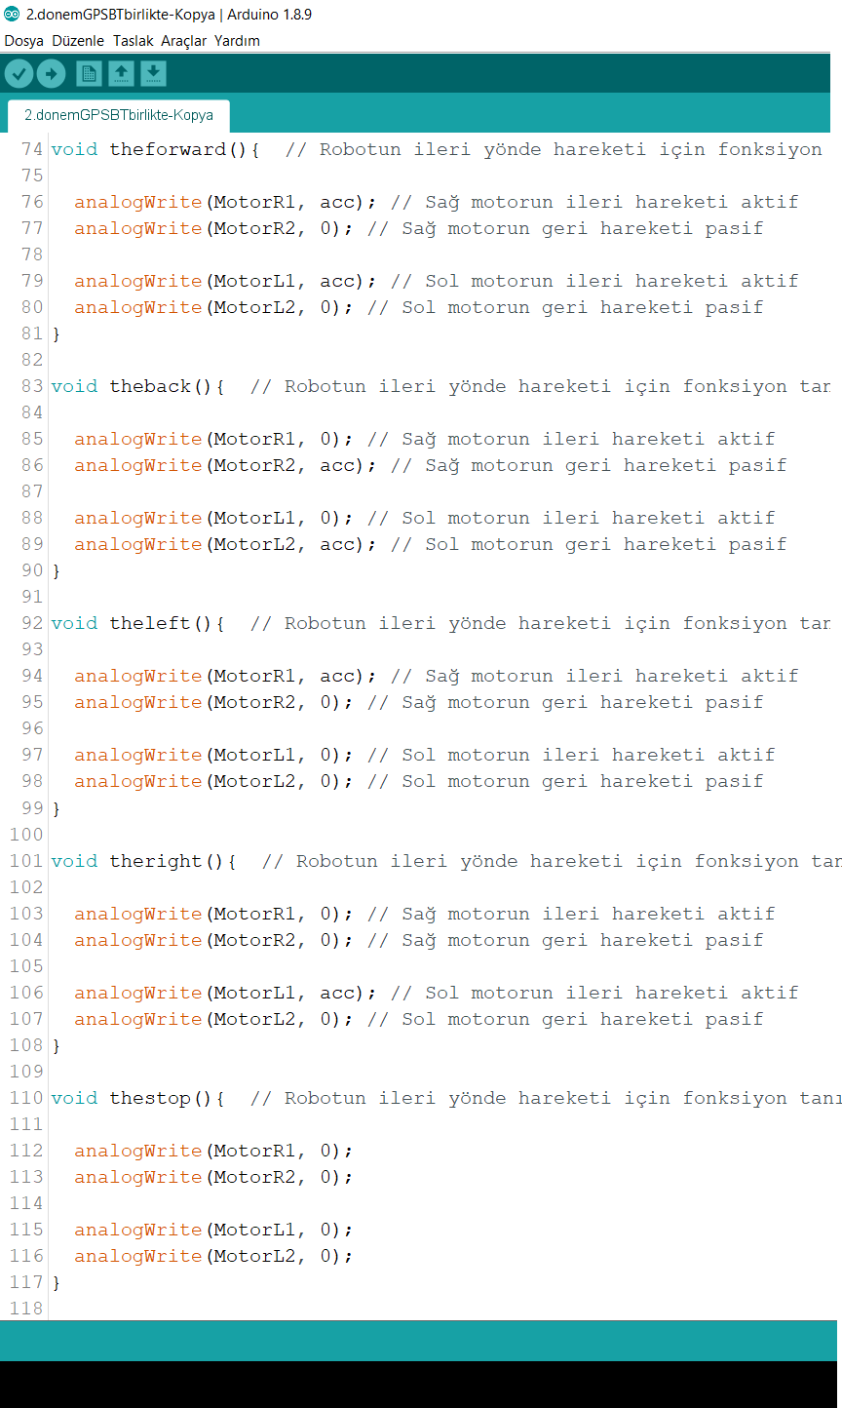

Figure . This code snippet shows how to working the robot movements

## Measuring Temperature & Humidity and Create Temperature & Humidity Graph

In our application, when we press the humidity or temperature button under the graphic text, it shows the graph of the time dependent change of the humidity or temperature values.

The following code produces measuring temperature & humidity values:

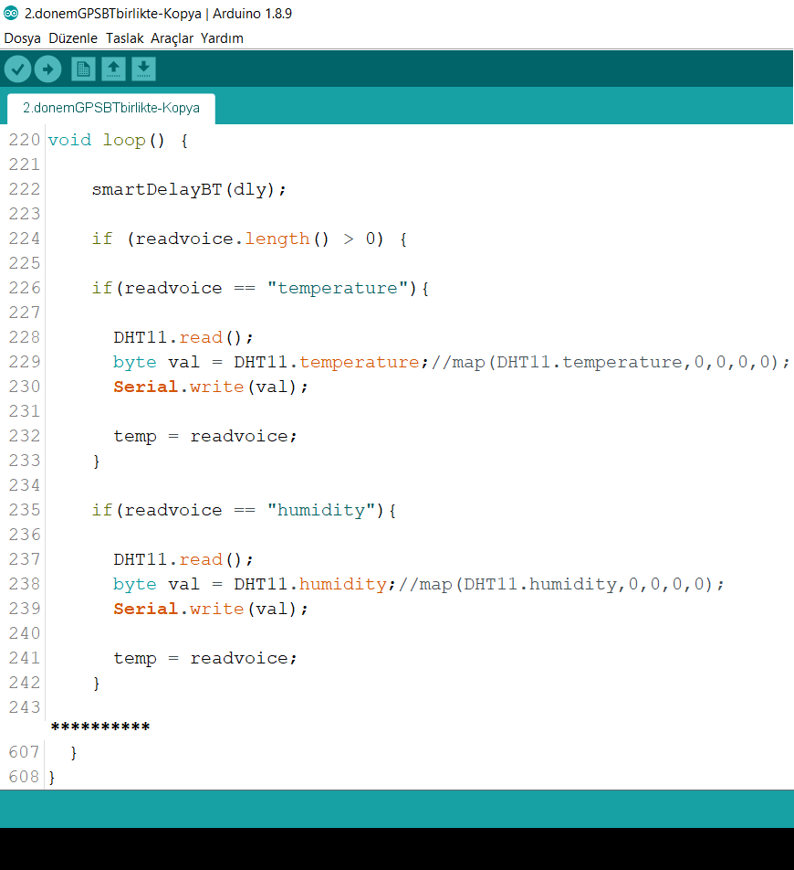

Figure . This code snippet shows how to showing temperature & humidity values

The following code shows the graph of the time dependent change of the humidity & temperature values:

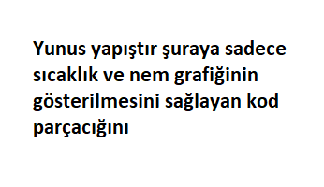

Figure . This code snippet shows how to showing temperature & humidity graphs[11]

## How to Measure Temperature & Humidity?

Because we will use the <dht11.h> library, which is one of the special libraries that measure temperature and humidity.

In the **void setup()** function, we define connecting pins to the sensor.

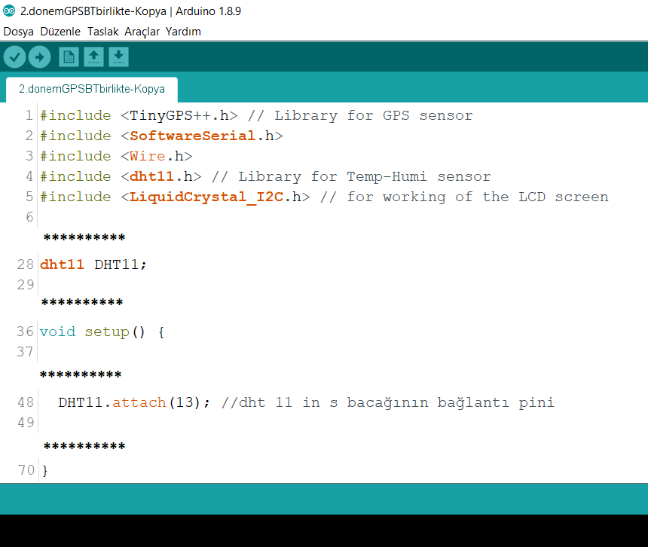Figure . This code snippet defines required libraries for measure temperature & humidity

## Obstacle Avoidance Mechanism

If the robot sees an obstacle during its movement, the robot turns back and changes its direction. We have integrated the ultrasonic distance sensor in the robot to provide this mechanism.

The following codes provides this function:

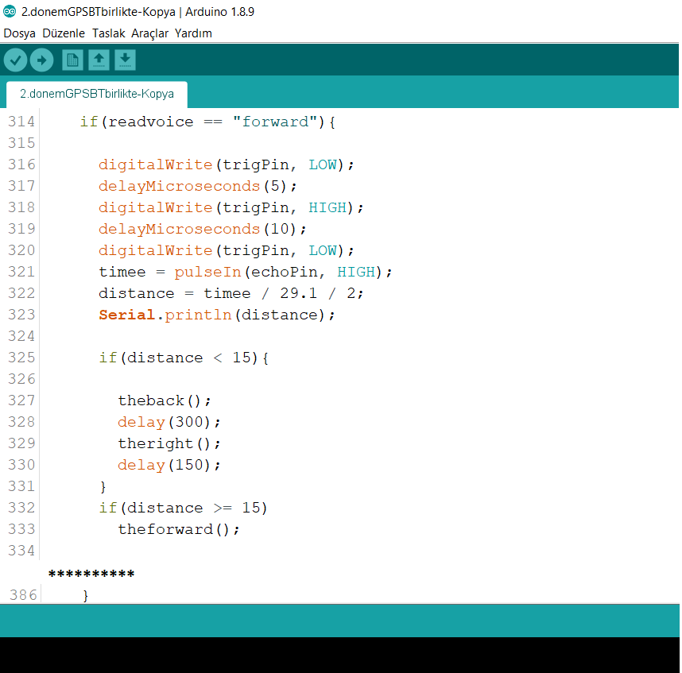Figure . This code snippet shows how to avoiding obstacle in the “Forward” command

## How to Measure Current Location of Our Robot?

### What is GPS (Global Positioning System)?

It is the device that can find its position on the Earth thanks to highly sensitive clock signals from at least 3 of the GPS satellites (if it includes altitude info, at least 4). GPS is a global positioning service developed by the US. In addition to GPS, GLONASS developed by Russia, IRNSS developed by India, BeiDou (BDS) developed by China and Galileo developed by European countries also have global positioning systems. All these systems are called global navigation satellite system (GNSS), but most of the time these systems are called GPS because it is the first system.[12]

The GPS operating principle is as follows: GPS satellites orbiting the Earth have very sensitive atomic clocks. These clocks work synchronously with other satellites and clockes on Earth and any deviation is corrected daily. Satellites in orbit and this is the precise time information they are constantly sending to Earth. When any GPS receiver in the world is operated, it requires signals from at least 3 of the GPS satellites in the coverage area, and GPS receiver that can learn the distance from each satellite is finding out how much diverted incoming clock information from absolute time, it can calculate the position on the world with this information.[13]

### Measure Current Location

First, we used a GY-NEO6MV2 GPS module to determine the current position of our robot. This module has a sensitivity of 5-10 meters (also see **Section 1.2.6**). In addition, indoor environment, trees, buildings, clouds can limit the view of the satellite and cause the error to be even larger.

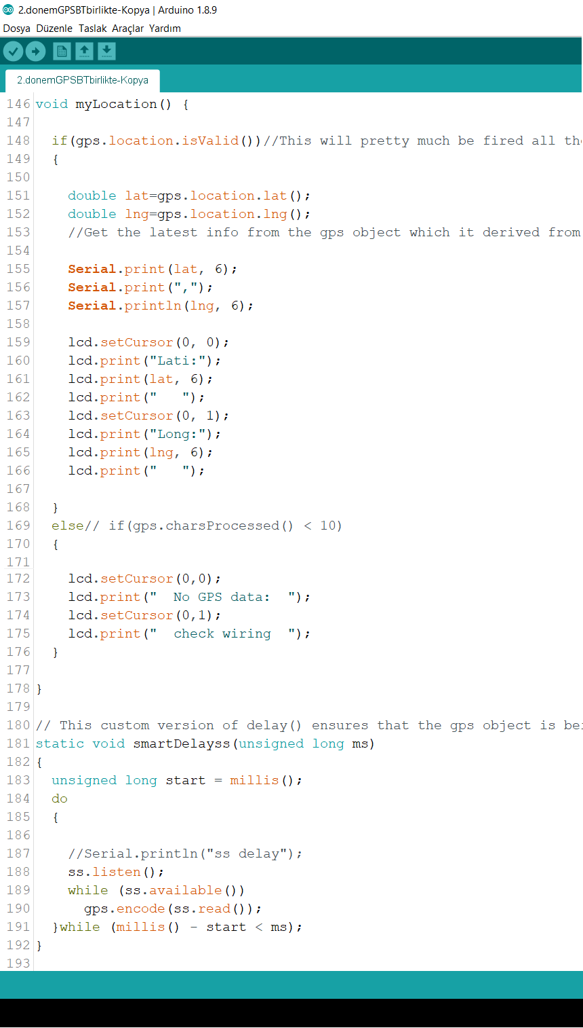 Figure . This code snippet shows how to measure current location of our robot

## Save Location from Arduino Serial Monitor to Text File

We have downloaded the **Processing**[14] platform to our Windows to save the location information that show at 115200 baud rate on the Arduino Serial Monitor to text file. Then we created the code in **Figure 2.7.1** and saved it in a folder.

When the Arduino UNO was connected to our computer, we started to run the code in **Figure 2.7.1** to save it in the text file instead of in the Serial Monitor. As soon as the code runs, it starts to save all values in the 115200 baud rate to text file.

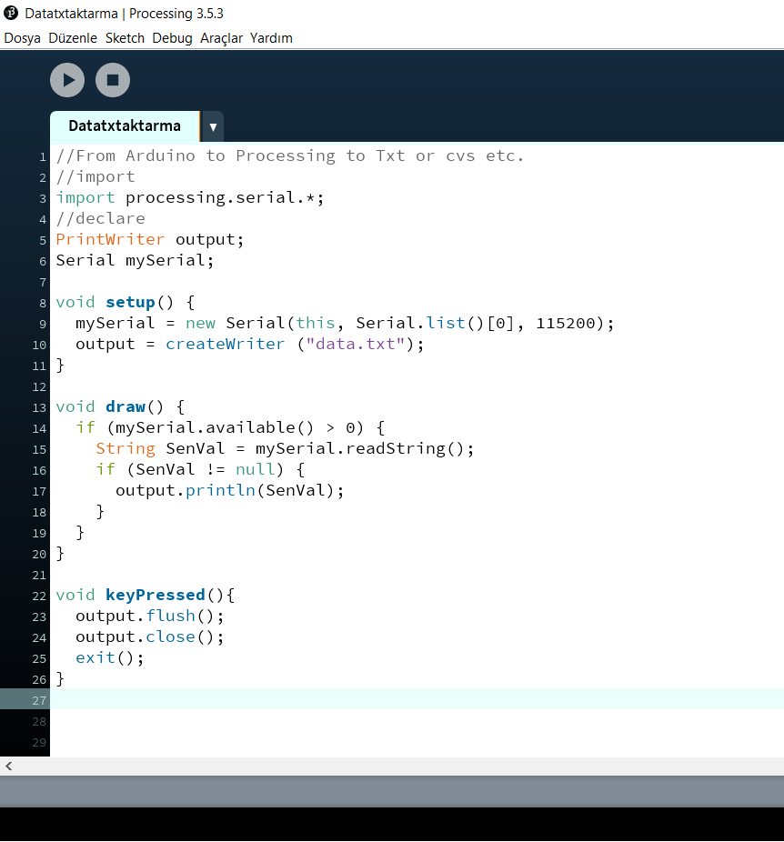Figure . This code snippet produces saving the values in Serial Monitor a text file

## Display Current Location of Our Robot in the Google Visualizer

### What does the Google Visualizer do?

**GPS Visualizer** (Do-It-Yourself Mapping) is an online utility that creates maps and profiles from geographic data. It is free and easy to use, yet powerful and extremely customizable. Input can be in the form of GPS data (tracks and waypoints), driving routes, street addresses, or simple coordinates. Use it to see where you've been, plan where you're going, or quickly visualize geographic data (scientific observations, events, business locations, customers, real estate, geotagged photos, etc.).[15]

Resize/colorize data points on a map: This is a special version of the GPS Visualizer map input form that's designed for plotting quantifiable data on a map. You can colorize and/or resize the points according to a generic frequency field named "N", or you can use a more typical field, such as altitude, population, or category.[16]

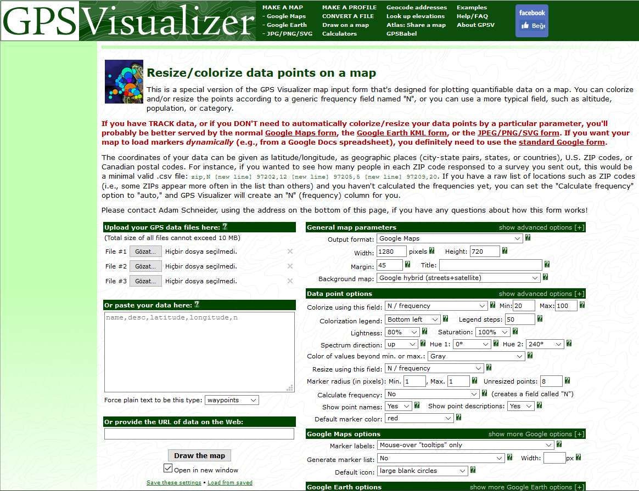 Figure . GPS Visualizer online platform

### Display Current Location

In addition to the latitude and longitude values that we saved in the text file on the Google Visualizer site, we also add temperature or humidity values as input. And these temperature or humidity values are also shown as “N” frequency input on the site. In addition, according to the values in the “N” frequency input temperature or humidity values in different color tones appear. (At high temperature, the color tones become darker; and at low temperature, the color tones become clear.)

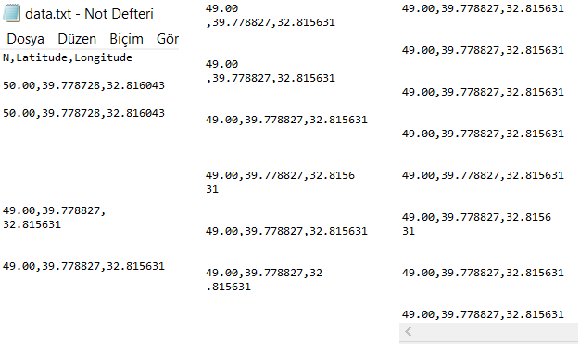

Figure . Text file example (N=humidity values)

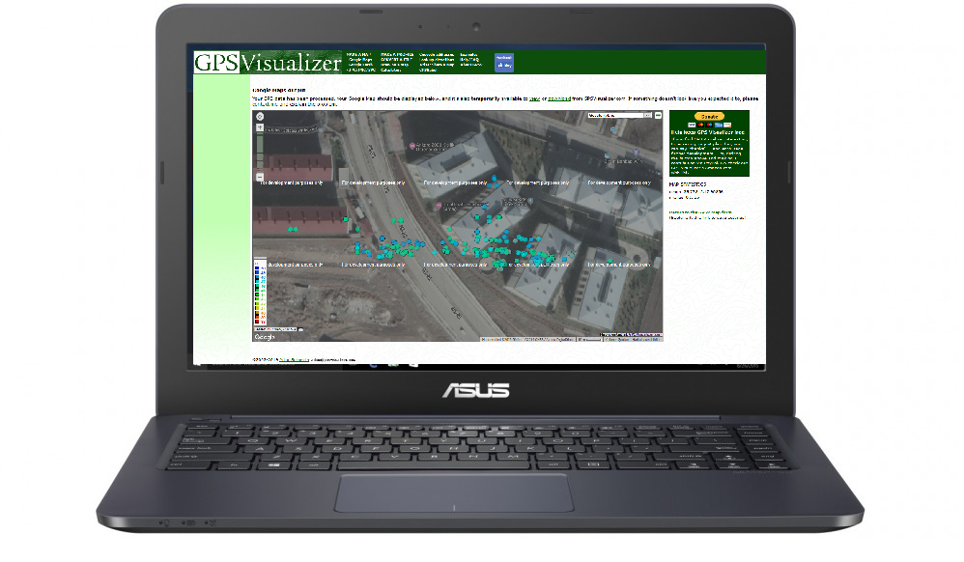Figure . Mapping on GPS Visualizer

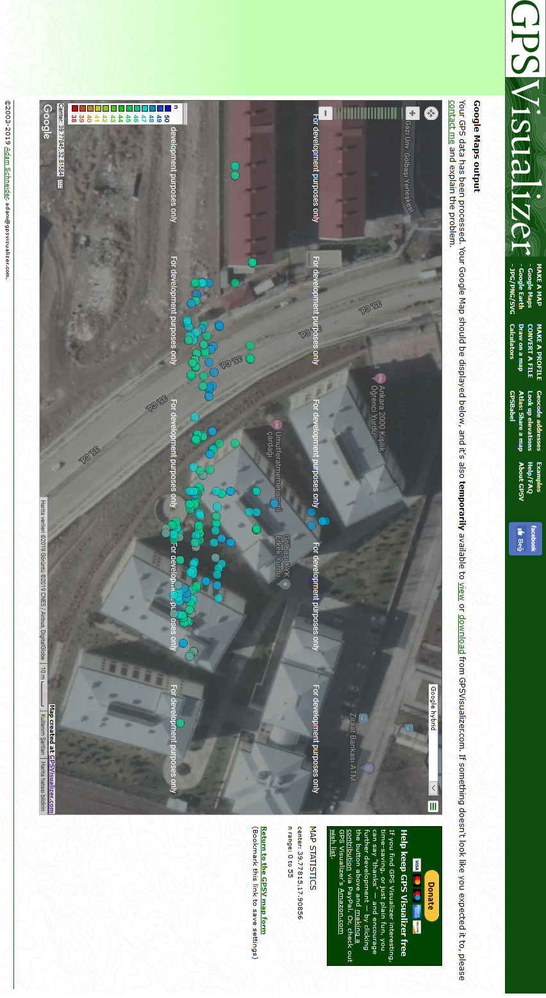 Figure . This is current location of our robot approximately[17]

# DEVELOP A PROPER APK APP FOR OUR ROBOT

## What does MIT APP Inventor Do?

## Create the Buttons for Robot Motions

## Create the Buttons for Measuring Temperature & Humidity Values

# UML DIAGRAMS OF THE SYSTEM

## Use Case Diagram

This is a use case diagram that better illustrates the functions of the system.

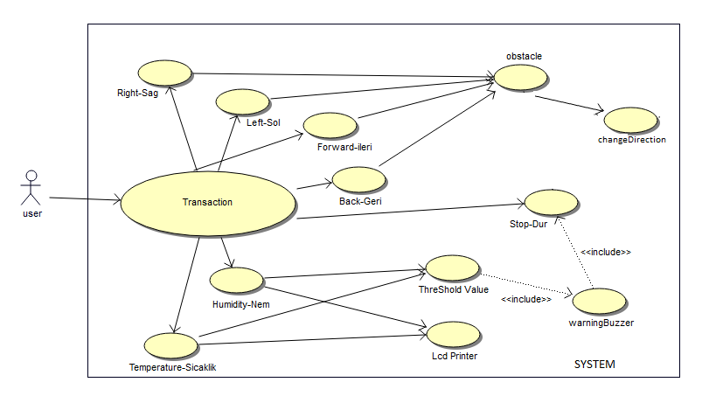Figure . Use Case Diagram of the robot

## Activity Diagram

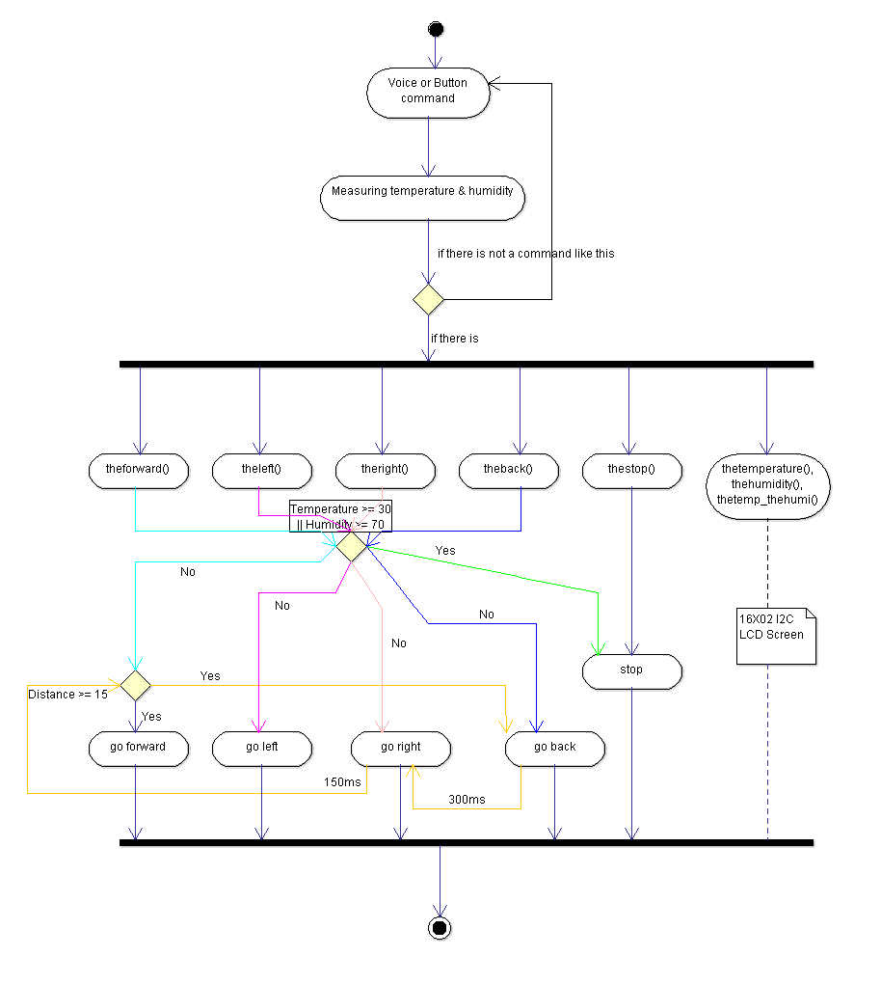

Figure . Activity Diagram of the robot

## Flow Chart

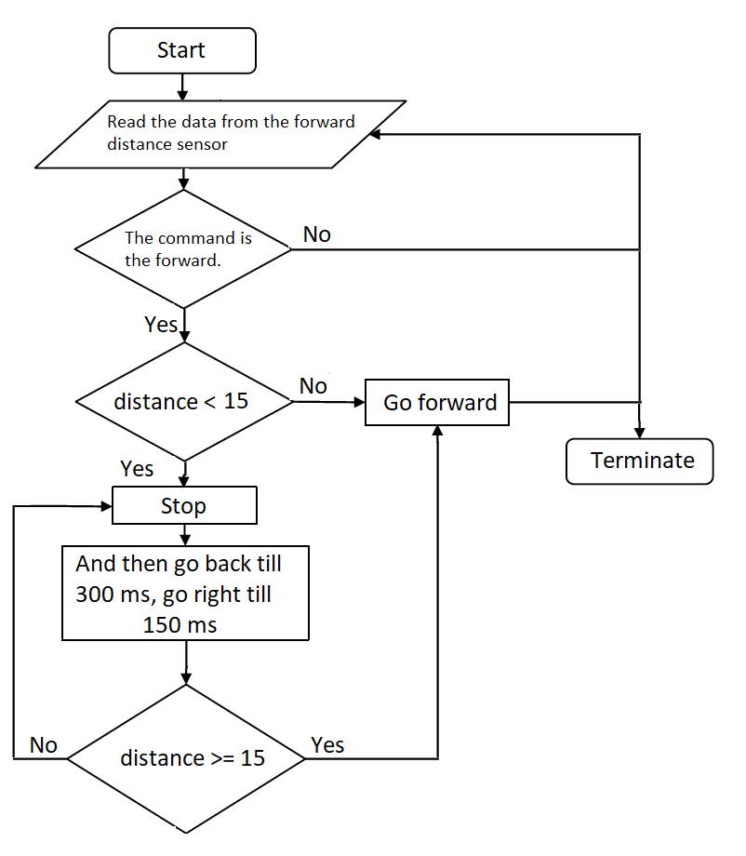Figure . Flow Chart of obstacle detection

# APPENDICES

In our robot, we used **Arduino UNO** as physical programming platform and required sensors and tools.

## Appendix-1. The Sensors used in the Robot

-HC-06 Bluetooth Module

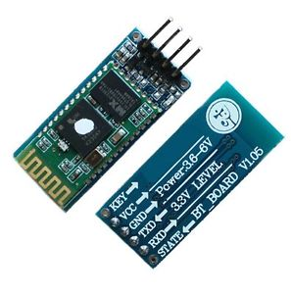

Figure Appendix-1.1. BT Module

-Stepper Motors with L298N Dual Motor Controller Module

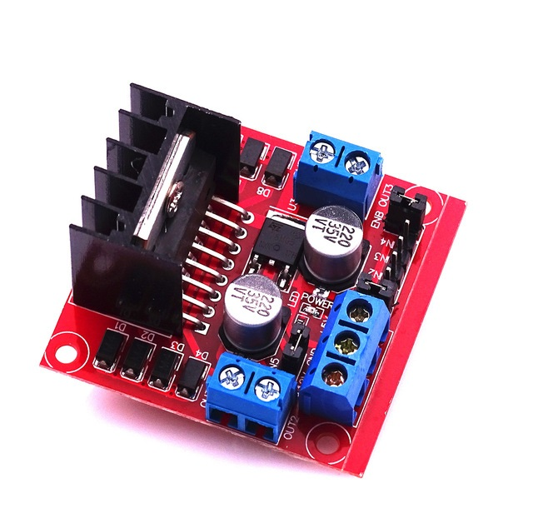

Figure Appendix-1.2. L298N Motor Driver

-Ultrasonic Ranging Detector Mod HC-SR04 Distance Sensor

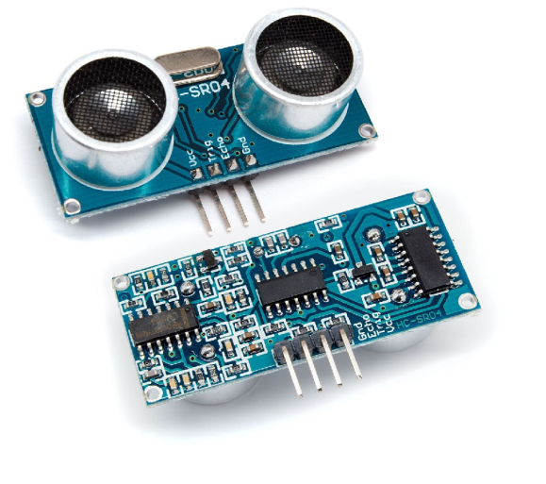 Figure Appendix-1.3. HC-SR04 Distance Sensor

-GPS Sensor

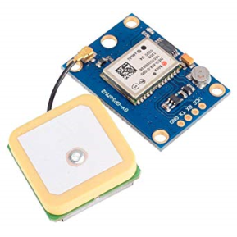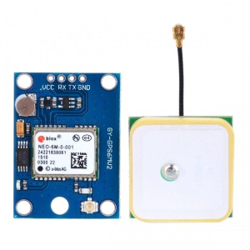

Figure Appendix-1.4. GY-NEO6MV2 GPS Modules

-DHT11 Temperature & Humidity Sensor

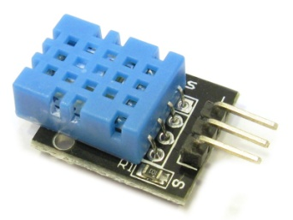

Figure Appendix-1.5. Temperature & Humidity Senso

## Appendix-2. The Tools used in the Robot

-4-wheel Robot Smart Car Chasis Kits

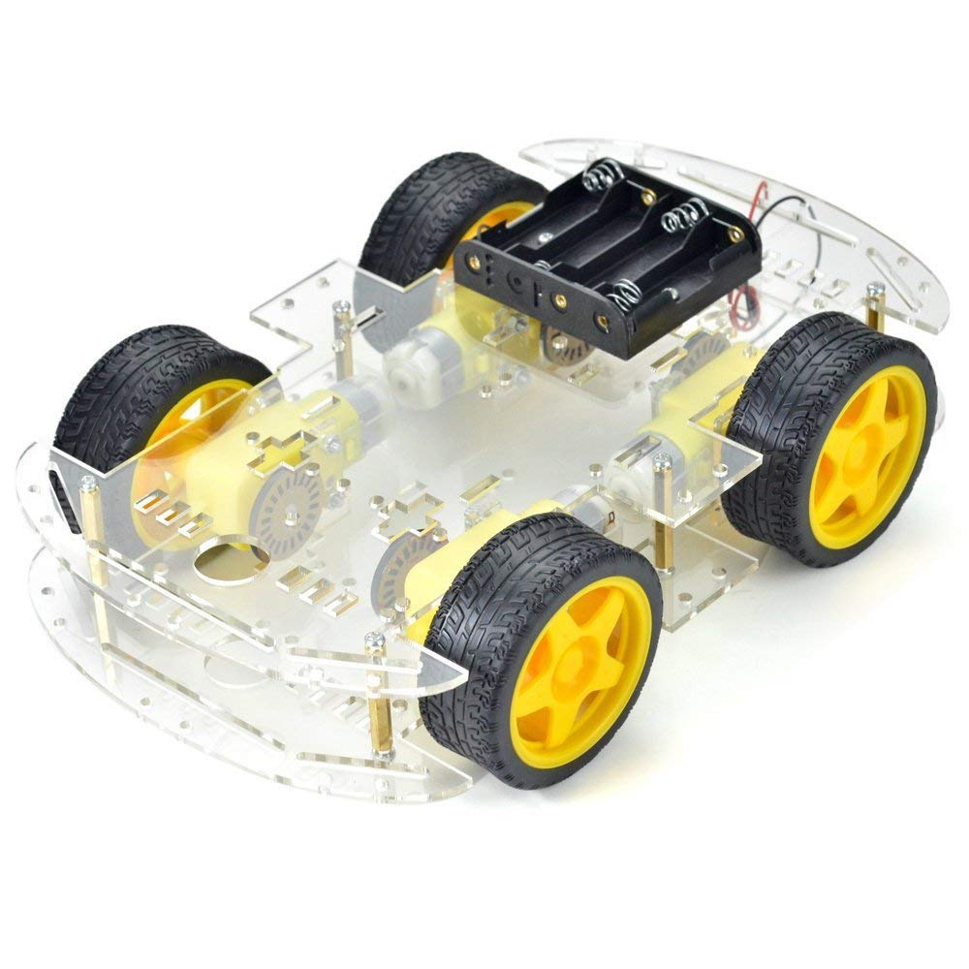

Figure Appendix-2.1. 4w Robot Smart Car

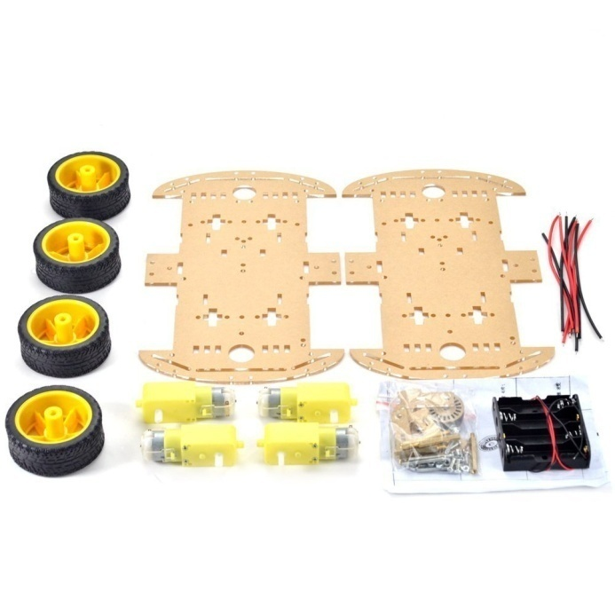

Figure Appendix-2.2. 4w Robot Smart Car

-IIC/I2C/TWI 1602 Serial LCD Module (R3Blue on White)

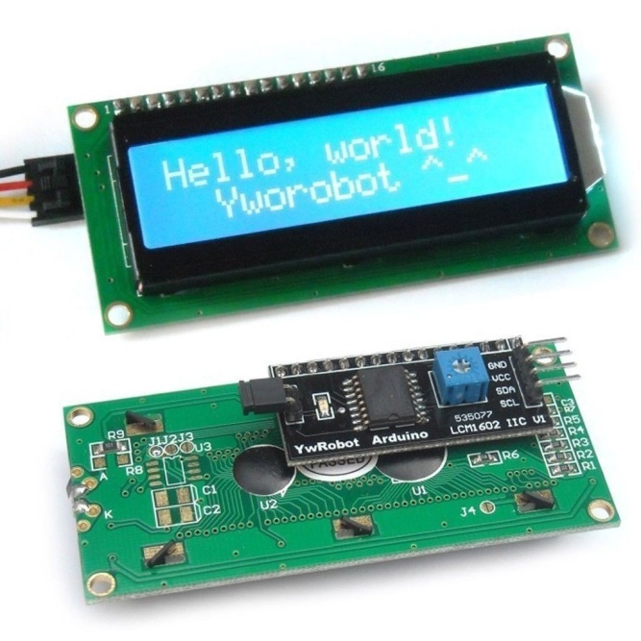

Figure Appendix-2.3. I2C LCD Module

-Mini Breadboard

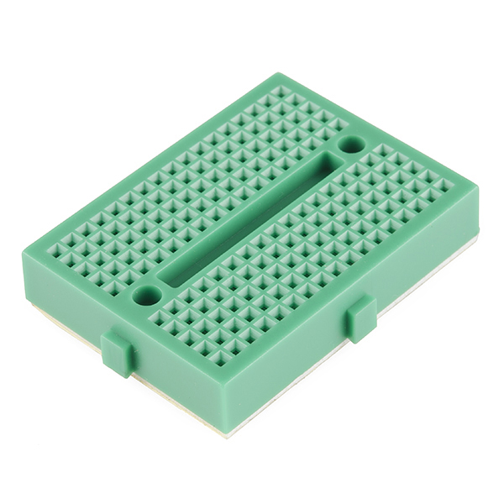

Figure Appendix-2.4. Breadboard

-Jumpers

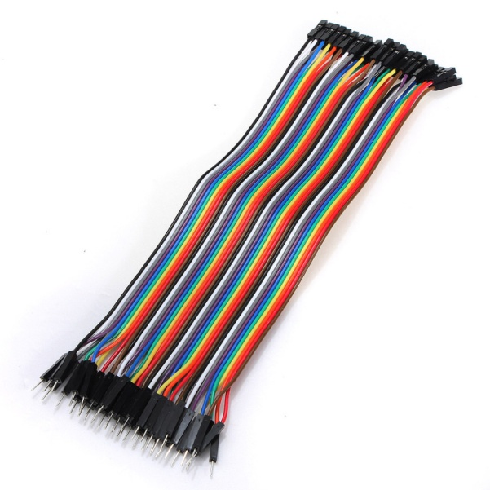

Figure Appendix-2.5. Male-Female Jumpers

-Male DC Barrel Plug Power Adapter

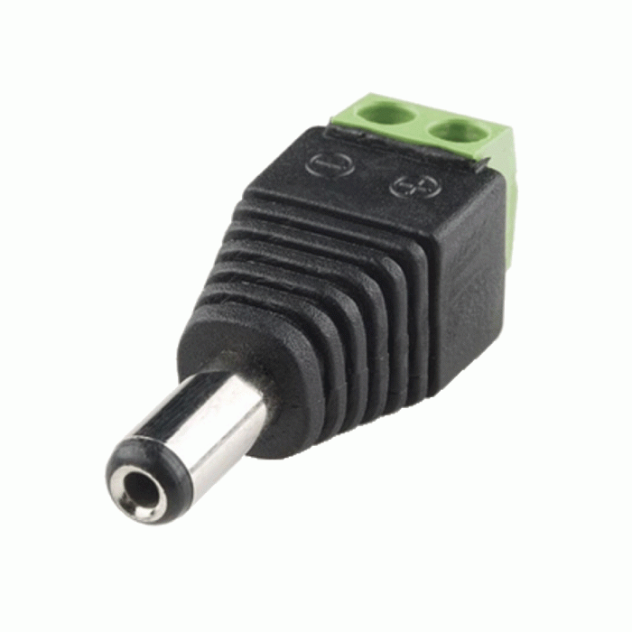

Figure Appendix-2.6. Barrel Plug Adapter

# CONCLUSION

This project has provided us with extensive knowledge of the Arduino software and electronical sensors. Since this project is related to both electronics and software, It made us to become familiar with both areas and to learn how to program electronic tool on Arduino.

We also learned to develop the APK application in this semester and determine the location of our robot according to the latitude, longitude data. Thanks to all these, we have learned to develop applications with MIT APP Inventor and to develop something both electronic and mechanical with Arduino.

# BIBLIOGRAPHY

MIT APP Inventor Platform, 2012, <https://appinventor.mit.edu/explore/>

Robot Nedir? Detaylı Robot Yapımı [Videolu], Tayfun Yağız Semiz, Oct. 02, 2017, <https://maker.robotistan.com/robot-nedir-yapimi/>

Gezgin Robotların Çiftliklerde Ürün Yeri Belirleme ve Taşıma İşlemlerinde Kullanımı, Özdemir Köse, 2008, PDF file, <http://dergipark.gov.tr/download/article-file/68349>

Arduino, <https://en.wikipedia.org/wiki/Arduino/>

Motor Driver Module-L298N, <http://wiki.sunfounder.cc/index.php?title=Motor_Driver_Module-L298N/>

DHT11 Isı ve Nem Sensörü Kart, <https://www.robotistan.com/dht11-isi-ve-nem-sensoru-kart/>

GPS Module for Arduino, cookingshacks, Nov. 15, 2010, <https://youtu.be/X3UfjpOWF0U>

Arduino Uno ile GY-NEO6MV2 GPS Modül Kullanımı, Kerem İzgöl, Nov. 24, 2015, <https://maker.robotistan.com/arduino-uno-ile-gy-neo6mv2-gps-modulu/>

GPS Nedir? Konum Tespiti Nasıl Yapılır?, Kerem İzgöl, Aug. 30, 2016, <https://maker.robotistan.com/gps-nedir/>

Processing is available for Linux, Mac OS X, and Windows, <https://www.processing.org/download/>

GPS Visualizer Resize/colorize Data Points on a Map, Adam Schneider, 2003, <http://www.gpsvisualizer.com/map_input?form=data>

Saving Arduino sensor data to a text file, Oct. 31, 2009, <https://electronics.stackexchange.com/questions/54/saving-arduino-sensor-data-to-a-text-file>

How to Export Data from Arduino Serial Monitor to a CSV or TXT File, Nicon, Dec. 26, 2015, <https://forum.arduino.cc/index.php?topic=367920.0>

[TUI]: Accelerometer write data to txt File, Christopher Fan, Nov. 26, 2013, <https://youtu.be/KHBcTK2qpf4>

Arduino fatal error: SoftwareSerial.h No such file or directory, Jul. 25, 2015, <https://jhorna.wordpress.com/2015/07/25/arduino-fatal-error-softwareserial-h-no-such-file-or-directory/>

Multiple Serial Communication on Arduino Uno, luckystar94, Jul. 09, 2014, <https://forum.arduino.cc/index.php?topic=254081.0>

Arduino ile Millis kullanımı ve Timer Uygulamaları, Oğuzhan Başer, Jul. 09, 2016, <http://www.elektrobot.net/arduino-ile-millis-kullanimi-ve-timer-uygulamalari/>

Millis Fonksiyonu Nedir ve Nerelerde Kullanılır?, May 05, 2016, <https://gelecegiyazanlar.turkcell.com.tr/konu/arduino/egitim/arduino-201/millis-fonksiyonu-nedir-ve-nerelerde-kullanilir>

Tutorial to Communicate Neo-6M GPS to Arduino, mybotic, <https://www.instructables.com/id/How-to-Communicate-Neo-6M-GPS-to-Arduino/>

Bluetooth Arduino RECEIVE data+Chart, Electronobs, Nov. 26, 2017, <https://youtu.be/JQ3tDhpmSFE>

Mobile CSP Map Tour Tutorial (Revised), Mobile Computer Science Principles, Jul. 13, 2018, <https://youtu.be/-pl9xYAK17I>

App Inventor: How to Access Google Maps Using Activity Starter, AndroidAppTraining, Jan. 10, 2012, <https://youtu.be/x2pglmHLQO4>

App Inventor 2 Tutorial-Arduino Bluetooth Control, Blue Matter, Jun. 21, 2015, <https://youtu.be/pR2rTRDZ_-Y>

How do I view Serial Output on an Android Device?, Aug. 19, 2014, <https://arduino.stackexchange.com/questions/3840/how-do-i-view-serial-output-on-an-android-device>

How to use your smartphone as a serial monitor for Arduino? 1Sheeld Tutorial, 1Sheeld, Aug. 10, 2015, <https://youtu.be/-oA4X9TnL3s>

Bluetooth Serial Monitor Android app, Nudge Me, Dec. 31, 2015, <https://youtu.be/YpvxgjdIOFw>

1. <https://appinventor.mit.edu/explore/> (online platform)
2. <https://maker.robotistan.com/robot-nedir-yapimi/>
3. <http://dergipark.gov.tr/download/article-file/68349> (pdf download)
4. <https://en.wikipedia.org/wiki/Arduino/>
5. <https://en.wikipedia.org/wiki/Arduino/>
6. <http://wiki.sunfounder.cc/index.php?title=Motor_Driver_Module-L298N/>
7. <https://www.robotistan.com/dht11-isi-ve-nem-sensoru-kart/>
8. <https://youtu.be/X3UfjpOWF0U>
9. <https://maker.robotistan.com/arduino-uno-ile-gy-neo6mv2-gps-modulu/>
10. “**********” means “there is a code that performs different functions”.
11. We have used the **MIT App Inventor** to develop our own APK application.
12. <https://maker.robotistan.com/gps-nedir/>
13. <https://maker.robotistan.com/gps-nedir/>
14. <https://www.processing.org/download/>
15. <http://www.gpsvisualizer.com/>
16. <http://www.gpsvisualizer.com/map_input?form=data>
17. Error margin is max 20-25 meter.